**Full Stack Development with MERN**

**Project Documentation**

**🏡 1. Introduction**

**Project Title: HouseHunt – Finding Your Perfect Rental Home**

**Team Members:**

* **Yedukondalu Mupparaju :**Backend Development, Schemas & Controllers
* **Sai Sri(Team Leader):** Backend Development, Routes & API Integration
* **Ruthika:** Frontend Development, Authentication, Inquiry & Booking Logic
* **Krishna:** Frontend Development, UI Design & Implementation

**🧭 2. Project Overview**

**Purpose**

HouseHunt is a MERN-stack based property rental platform that connects renters, property owners, and administrators. Users can browse homes, apply filters, send inquiries, and track responses. Owners can manage listings and inquiries through a dedicated dashboard, and admins monitor and promote verified listings.

**Features**

* User authentication (signup, login with JWT)
* Browse/filter rental properties
* Inquiry system to connect renters with owners
* Property listing management (add/update/delete)
* Owner dashboard for property management
* Admin panel for verifying and promoting listings

**🏗️ 3. Architecture**

**Frontend (React.js)**

* React Router for dynamic page routing
* Context API for global state management
* Reusable UI components (header, cards, inquiry forms)

**Backend (Node.js + Express)**

* REST API for property listings, user/owner/admin management
* Role-based access control
* JWT for secure sessions

**Database (MongoDB)**

* Stores user, owner, property, and inquiry data
* Data schema separation by roles and listing types

**⚙️ 4. Setup Instructions**

**Prerequisites**

* Node.js ≥ 14.x
* MongoDB (local or Atlas)
* npm

Installation

git clone https://github.com/your-repo/HouseHunt.git

Frontend

cd client

npm install

npm start

Backend

cd server

npm install

npm start

**Environment Setup**

* **Frontend: .env →** REACT_APP_API_URL=http://localhost:5000
* **Backend: .env →** MONGO_URI, JWT_SECRET, PORT

**📁 5. Folder Structure**

**client/**

* src/components/ – Reusable UI elements (Navbar, Footer, PropertyCard)
* src/pages/ – Pages (Home, PropertyDetails, CreateListing)
* src/context/ – Auth and UI context providers

**server/**

* routes/ – API endpoints (auth, properties, inquiries)
* controllers/ – Logic for CRUD operations
* models/ – Mongoose schemas (User, Property, Inquiry)
* middleware/ – Auth middleware, error handling
* config/ – DB connection, environment setup

**▶️ 6. Running the Application**

**To start locally:**

bash

CopyEdit

cd client

npm start

bash

CopyEdit

cd server

npm start

**📡 7. API Documentation**

**User Endpoints**

* POST /api/register – Register renter
* POST /api/login – Login renter
* GET /api/profile – Authenticated user data

**Property Endpoints**

* GET /api/properties – All properties
* POST /api/properties – Create listing (Owner only)
* PUT /api/properties/:id – Edit property
* DELETE /api/properties/:id – Delete property

**Inquiry Endpoints**

* POST /api/inquiries/:propertyId – Submit inquiry
* GET /api/inquiries – View sent/received inquiries

**Admin Endpoints**

* GET /api/admin/properties – All properties for verification
* PATCH /api/admin/promote/:id – Promote verified property

**🔐 8. Authentication**

**Passwords**

* Hashed with bcrypt before DB storage
* Compared securely on login

**Session Handling**

* JWT issued on login
* Stored client-side in React Context

**Role-Based Access**

* **Roles:** Renter, Owner, Admin
* Conditional rendering in UI and backend routes

**🧑‍💻 9. User Interface**

**Key UI Elements:**

* **Homepage:** Browse promoted and new listings
* **Property Details Page:** Shows images, features, and inquiry form
* **Owner Dashboard:** CRUD for listings, view inquiries
* **Admin Dashboard:** List and promote verified listings

**🧪 10. Testing**

**Testing Strategy**

* **Unit Tests:** API routes and DB models
* **Integration Tests:** Renter-to-owner inquiries
* **Manual Testing:** Functional flows like login, property CRUD, inquiry

**Tools Used**

* **Jest:** Unit testing
* **Supertest:** API testing

**🖼️ 11. Screenshots**

***(Add real screenshots during project review)***

* **Login page**

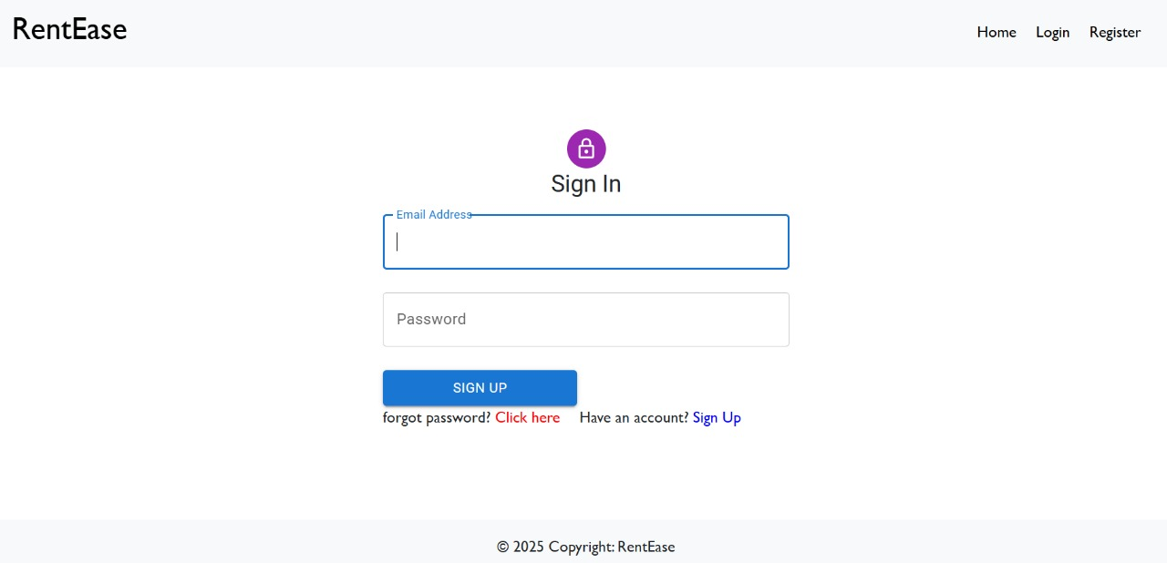

* **Property Listing**

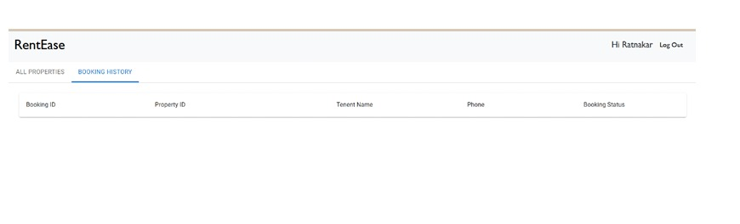

* **Registration Page**

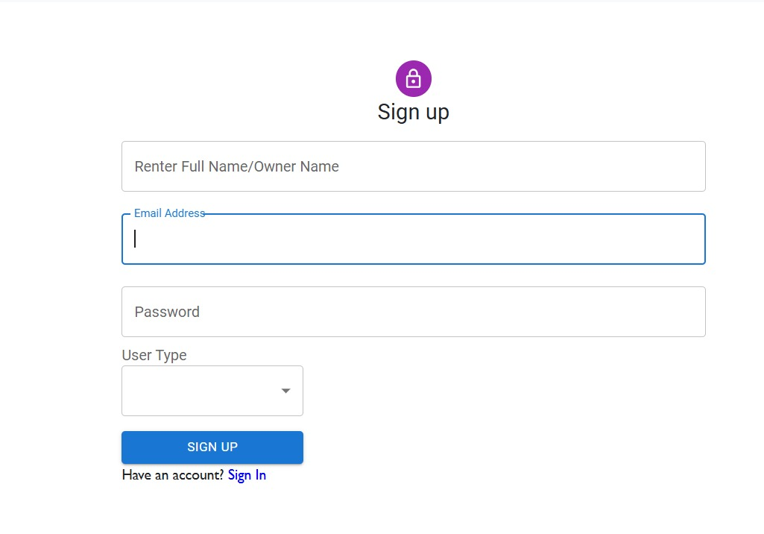

* **Owner Dashboard**

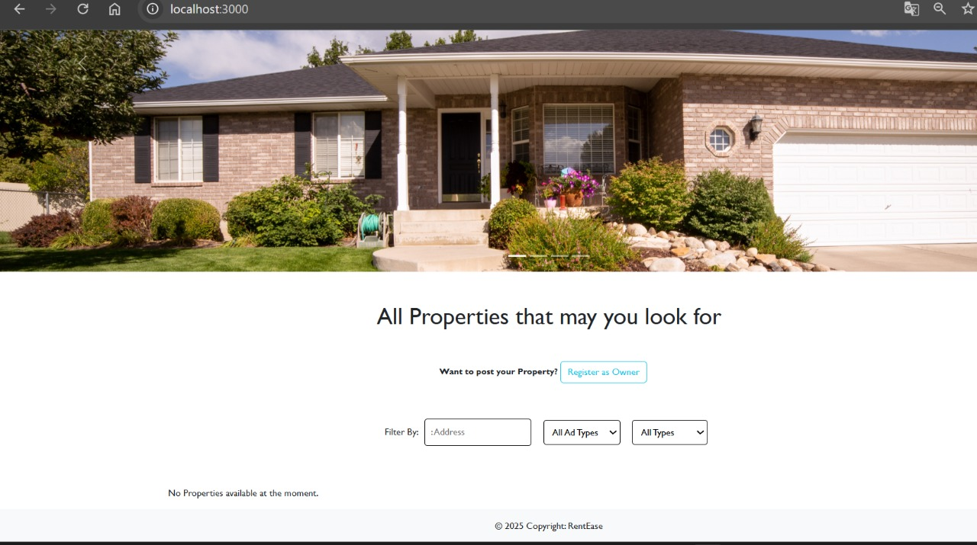

**⚠️ 12. Known Issues**

* No real-time chat between renter and owner
* No payment gateway or booking calendar yet
* Limited filtering options (to be improved)

**🚀 13. Future Enhancements**

* Add secure payment gateway for deposits
* Build mobile app using React Native
* Integrate real-time chat and notifications
* Advanced filters (price range, furnished, etc.)
* Admin analytics and fraud reporting tools